In R, factors are used to handle categorical data. A factor is a data structure that stores both the values of categorical data and their corresponding levels. Factors are particularly useful when dealing with nominal or ordinal data.
Key Features of Factors:
- Levels: Factors store distinct categories or levels. For example, if you have a variable "Gender" with values "Male" and "Female", R will store these as factor levels.
- Nominal vs. Ordinal:
  - Nominal factors: Categories with no intrinsic order (e.g., colors: "Red", "Green", "Blue").
  - Ordinal factors: Categories with a specific order (e.g., education levels: "High School", "Bachelor's", "Master's", "PhD").
- Creating Factors in R:
To create a factor, use the factor() function.
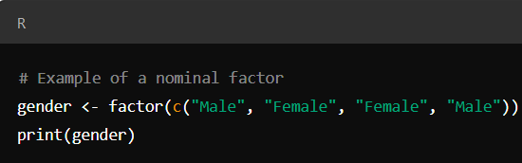
This will print:
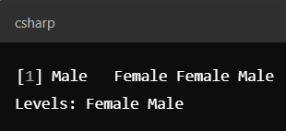
Creating Ordinal Factors:
To specify an order for ordinal factors, you can use the ordered = TRUE argument:
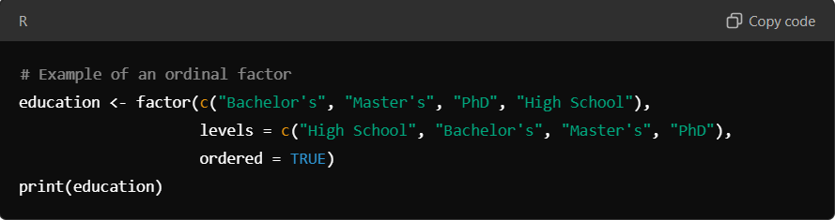
This will print
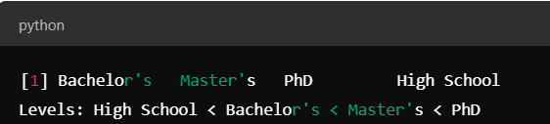
Common Functions with Factors:
- levels(): Get or set levels of a factor.
- table(): Summarize counts of each factor level.
- as.numeric(): Convert factor to numeric values.
- as.character(): Convert factor to character values.

Exercise on Factors
1. Create a Factor
Question: Create a factor called fruits from the following vector: c("apple", "banana", "cherry", "apple", "cherry", "banana", "apple"). Check the levels of the factor.
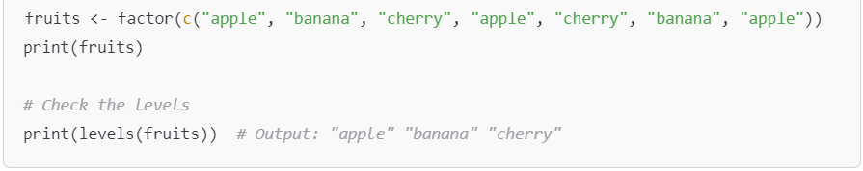

2. Change Factor Levels
Question: Using the fruits factor from the previous exercise, change the level "cherry" to "strawberry".
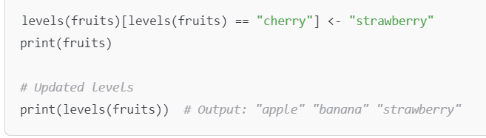

3. Reordering Factor Levels
Question: Reorder the fruits factor so that "banana" comes first, "apple" second, and "strawberry" third.
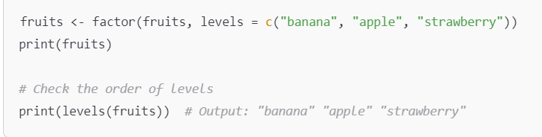

4. Check if a Variable is a Factor
Question: Check if fruits is a factor using the appropriate R function.
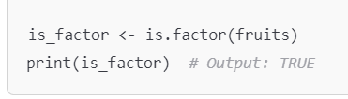
5. Convert a Factor to Numeric
Question: Convert the fruits factor into its underlying numeric values.
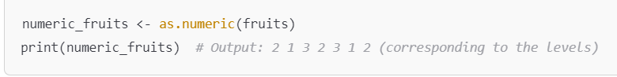

6. Frequency Count of Factor Levels
Question: Use table() to count the occurrences of each level in the fruits factor.
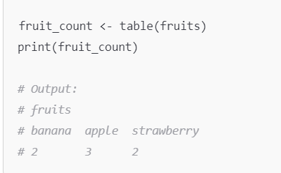
7. Create an Ordered Factor
Question: Create an ordered factor called ratings from the vector c("low", "medium", "high", "medium", "low", "high"). The order should be: "low" < "medium" < "high".
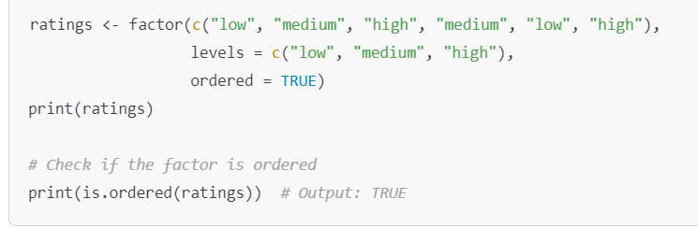
8. Compare Levels of Ordered Factor
Question: Using the ratings factor from the previous exercise, check whether the first element ("low") is less than the second element ("medium").

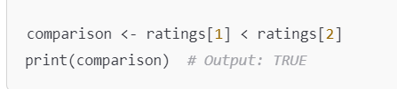
9. Creating a Factor with Missing Levels
Question: Create a factor sizes from the vector c("small", "large", "medium", "large", "small", "medium"). Ensure that the factor includes a missing level "extra_large", even though it's not in the data.
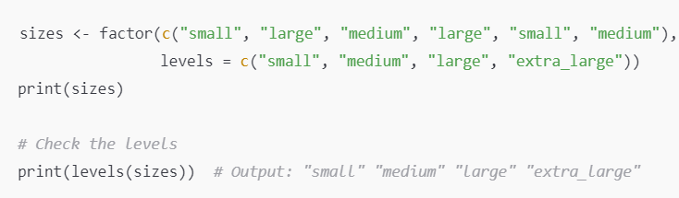

10. Dropping Unused Levels
Question: Create a factor colors from the vector c("red", "blue", "green", "blue", "green", "red") with levels c("red", "blue", "green", "yellow"). Drop the unused level "yellow".
